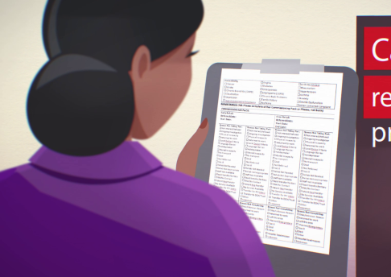
What information do we collect?
As part of your care, your speech and language therapist collects information about you, including any difficulties you have with your speech, language, communication or swallowing. This is done using Therapy Outcome Measures (TOMs). This information is collected at the beginning, during and end of your therapy. It is used to monitor change over time and to support us with providing high quality speech and language therapy for you and others.

How do we use it?
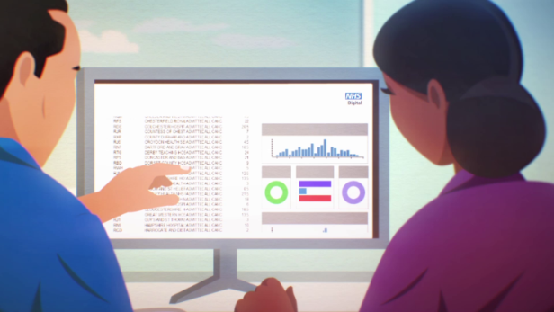
We enter information about TOMs into an online database developed by the Royal College of Speech and Language Therapists (RCSLT) called the ROOT. We provide information about your age, gender and reasons for receiving speech and language therapy. We do not provide personal details such as your name, date of birth or address. Your speech and language therapy service and the RCSLT are fully committed to keeping information about you safe.

Why do we need it?

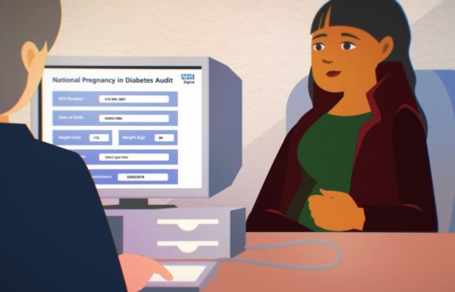
We use this information to support your therapy, as well as to monitor the effectiveness and quality of the service we provide to the children, young people and adults accessing speech and language therapy. Using the ROOT helps us to know what is working well and what can be improved. For example, we can find out how many 5-11 year olds have better language skills after their speech and language therapy sessions, or how many individuals with head injury have greater independence following their treatment.
We can also compare our service with other services in different parts of the country to help us to learn from each other.

I want to know more
Please ask your therapist for further information. You can also go to the RCSLT website https://www.rcslt.org/speech-and-language-therapy/guidance-for-delivering-slt-services/outcome-measurement/outcome-tool-overview/

Enderby P, John A. Therapy outcome measures for rehabilitation professionals, Third Edition. Guildford: J&R Press Ltd, 2015.
The RCSLT is the professional body for speech and language therapists in the UK. You can find further information on the RCSLT website: https://www.rcslt.org/about-us
Local services to amend as appropriate (Images by Understanding Patient Data used under CC BY)

