Why do you collect information about me?
Image of local SLT/team | Your speech and language therapist collects information about you as part of your speech and language therapy.
 | We use it to find out what is working well and what we need to work on in speech and language therapy.
 | We also use this information to make our service better for you and other people.

What information do you collect?
 | We collect information about the difficulties that you have with your communication, or eating and drinking.
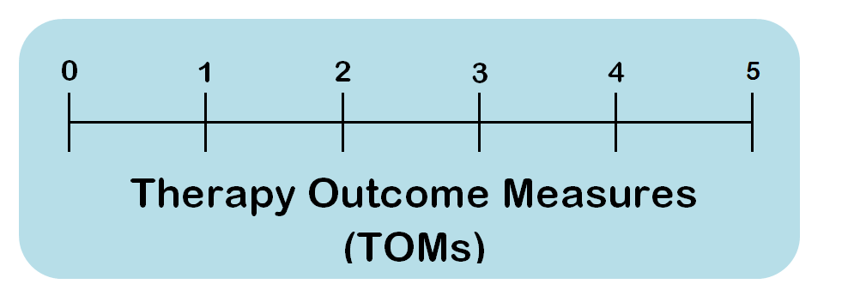 | We use a tool called Therapy  Outcome Measures (TOMs)  to help with this.
We use the TOMs at the start
and end of your speech and language therapy.

How do you use it?
 | We enter some of the information we collect into an online database called the ROOT.
 | We enter information about your age, gender, TOMs scores and reasons for receiving speech and language therapy.
 | We do not enter personal details such as your name or address.
 | The ROOT has been developed by the Royal College of Speech and Language Therapists (RCSLT).
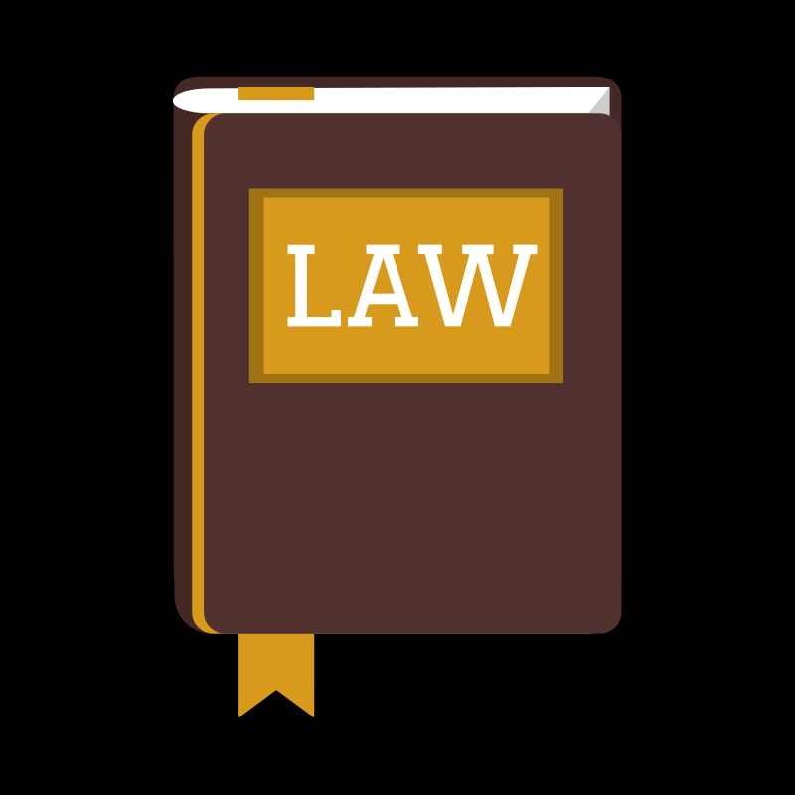 | There are strict rules to make sure that information is kept safely. Your speech and language therapy service and the RCSLT carefully follow these rules.

I want to know more

Image of local SLT/team | Please ask your speech and language therapist for more information.
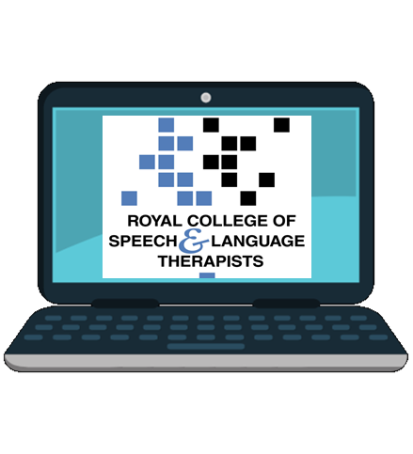 | There is also more information about  the ROOT on the RCSLT website https://www.rcslt.org/speech-and-language-therapy/guidance-for-delivering-slt-services/outcome-measurement/outcome-tool-overview

