**Why it is important to use patient data?**

As part of your care, your speech and language therapist collects information about you, including information on the any difficulty you may have with your speech, language, communication or swallowing. This is done using Therapy Outcome Measures (TOMs[1]). This information is collected at the beginning, during and at the end of your course of speech and language therapy. It is used to monitor change over time and to support the delivery of high quality speech and language therapy for you and others.

As well as supporting your care, we also use this information to check the effectiveness of our service and improve the quality of care provided to those accessing speech and language therapy.

**What happens to your data? Who sees it? Is the data identifiable?**

The information collected by your speech and language therapist is recorded in full in your patient record. This is confidential and is only seen by health and care professionals directly involved in your care. However, some of this information is entered into an online database developed by the Royal College of Speech and Language Therapists (RCSLT)[2], called the ROOT.

This dedicated database does **not** include personal details such as your name, date of birth or address but it will contain information about your age, gender and reasons for receiving speech and language therapy. This information about you is ‘de-personalised’. This means that the information recorded does not contain details that reveal your identity. However it is not completely anonymous because, it is possible that by piecing together different pieces of information someone might be able to identify you but this is highly unlikely. Figure 1 illustrates where ‘de-personalised’ information sits on a continuum between ‘more identifiable’ to ‘less identifiable’:

: 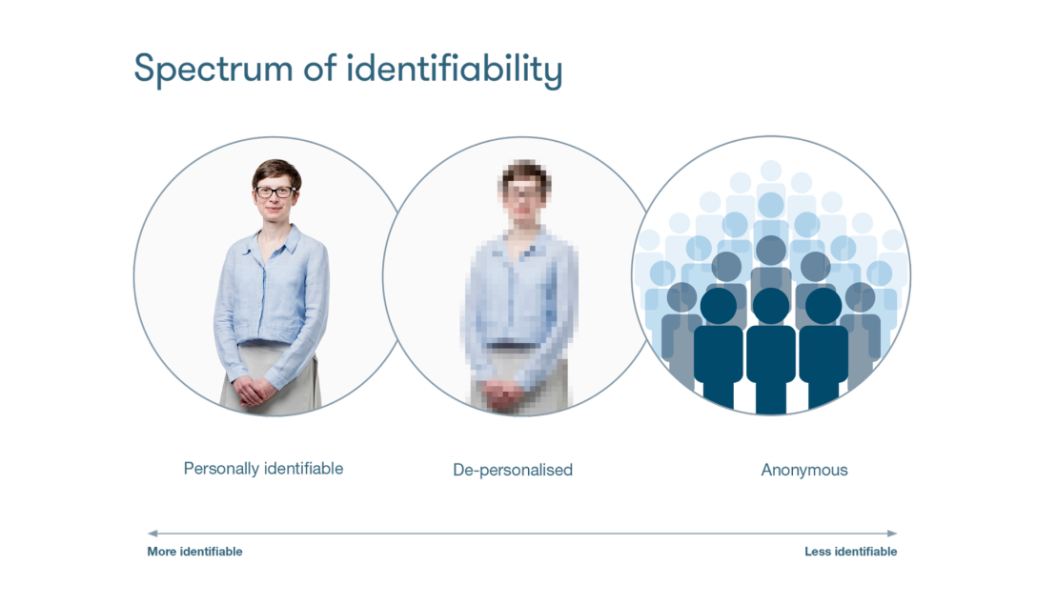

*Figure 1 Identifiability of patient information (Source: Understanding Patient Data)*

Your speech and language therapy service can use the de-personalised information about you on the ROOT to create reports about the care of their patients. Your speech and language therapy service and the RCSLT are fully committed to keeping information about you safe and there are robust controls in place to protect your privacy.

De-personalised data about you is also combined with other de-personalised data to generate statistical data. *These reports tell us things like how many 5-11 year olds have better language skills after their speech and language therapy sessions, or how many individuals with head injury have greater independence following their treatment[3].* In these reports, it is not possible to identify you as an individual. These anonymised reports are available to other speech and language therapists and the RCSLT.

**What are the risks?**

Using patient data will never be completely without risk, but by ‘de-personalising’ the data about you before it is entered into the ROOT, the risks are minimised. Nevertheless, potential risks include:

* **Loss of privacy**: If you have a rare condition or unusual treatment plan, it is possible that the information recorded on the ROOT would become ‘more identifiable’ on the continuum (see figure 1).
* **Unauthorised access to the database**: There is a possibility that individuals without a legitimate reason could gain access to the database and they would then have access to de-personalised data about you.

However, there are also risks of not using the data. It is important that we understand what is working well and what can be improved to ensure that we are providing safe and effective speech and language therapy and not wasting resources.

**What are the safeguards?**

To minimise the risks described above, a number of safeguards have been put in place. These include:

* **Storing your information securely:** The information about you is stored securely and protected. The ROOT is kept safe and secure with robust IT security.
* **Auditing the use of the database**: Every time someone accesses the ROOT a record is made about who they are and what data they saw. This makes it possible to detect any access to the database that may not be legitimate.
* **Putting strict legal contracts in place**: This is to ensure that your information is used lawfully.
* **Ensuring the reports on statistical data does not reveal the identity of patients:** Controls have been put in place to prevent the reports on statistical data from potentially identifying you. For example, statistics on a cohort of fewer than 6 individuals will not show up.

For full details of the risks and safeguards, please contact the RCSLT for a copy of the ROOT data protection impact assessment: [ROOT@rcslt.org](mailto:ROOT@rcslt.org).

**What’s allowed? What’s not allowed?**

The information provided on the ROOT is to be used for the purposes of supporting your individual care and improving speech and language therapy services. The information on the ROOT will not be used for commercial, marketing or insurance purposes. The statistical reports might be shared outside of our speech and language therapy department, *for example, in reports to managers who help plan NHS services[4]*.

Access to the ROOT is carefully monitored and controlled, and complies with existing standards and the law.

**What choices do you have?**

Information about your speech and language therapy is recorded as an essential part of your care. However, you have a right to know about how the personal data about you is processed. You also have a right to request access to this information. Please speak to your speech and language therapist with any questions about this.

**Why do companies need access to data?**

Employees of the RCSLT and Different Class Solutions Ltd (the company processing the speech and language therapydata) can access the ROOT database containing the de-personalised data. However, this will only be necessary in the event of resolving a technical issue.

On the whole, the RCSLT and Different Class Solutions Ltd will only need access to the statistics and anonymised reports generated by the ROOT. These are also available to other speech and language therapy services. This is needed to improve the quality of speech and language therapy across the country.

**How can you find out more?**

Please ask your speech and language therapist, who can provide you with further information about the ROOT, or visit <https://www.rcslt.org/speech-and-language-therapy/guidance-for-delivering-slt-services/outcome-measurement/outcome-tool-overview/> .

To find out more information about the use of patient data in health and care, please visit: <https://understandingpatientdata.org.uk/>

1. Enderby P, John A. Therapy outcome measures for rehabilitation professionals, Third Edition. Guildford: J&R Press Ltd, 2015.
2. The RCSLT is the professional body for speech and language therapists in the UK; providing leadership and setting professional standards. Please visit the RCSLT website for further information: <https://www.rcslt.org/about-us>
3. Local services to amend as appropriate
4. Local services to amend as appropriate